Last Updated: 8/18/2021
This QRG outlines the process of Creating a Position (Add Peer Position or Lower Level Position) in SuccessFactors.
Note: To create a completely new position number, create a similar lower level position and work with the West Lafayette Compensation Department for the appropriate edits.

Assigning Roles to Positions and other updates due to new position
- Access the Role Request form and review the Roles and Privileges Information tiles located in SuccessFactors.
- SuccessFactors groups (approval workflow) may need updating, if position is department head, budget approver or within Human Resources. Reach out to the Who to Contact list on the Roles and Privileges Information tile.

Quick Links: Access SuccessFactors, Creating a Position, Add Peer Position, Lower Level Position

When to Create a Position (Add Peer Position or Lower Level Position)
A new position (or mass position) is typically created when a hiring action needs to occur.

Creating a Position (Add Peer position or Lower Level Position) Process
The Initiator receives a request to create a position and processes it in SuccessFactors. Once complete, it is routed to HR Compensation (HR Admin-Position) via the workflow process for either approval or rejection.

Access SuccessFactors
Visit OneCampus and select Employee Launchpad or from the Employee Self-Service web page click SuccessFactors  Log in using Purdue Career Account ID and Password. | https://one.purdue.edu/  https://www.purdue.edu/hr/global/pgnew.php  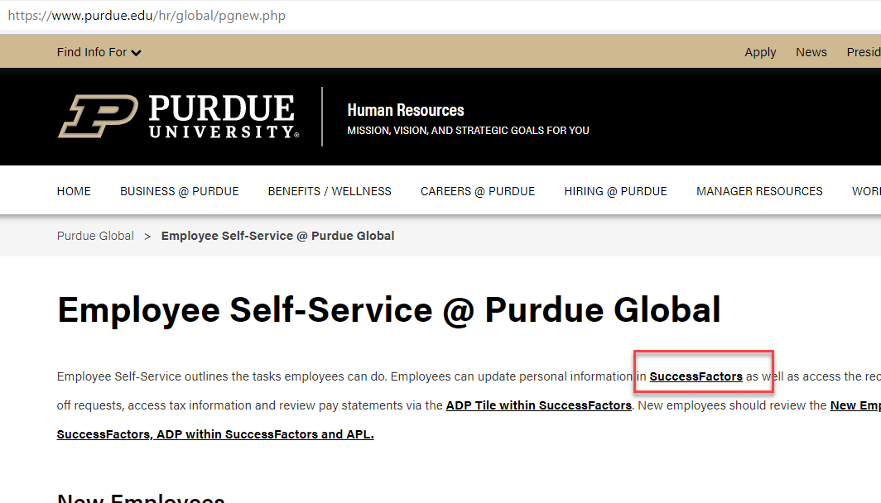

Creating a Position (Add Peer Position or Lower Level Position)
Select Company Info from the dropdown menu under Home.  Click Position Org Chart | 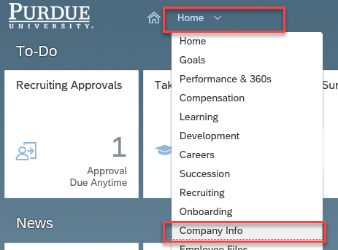  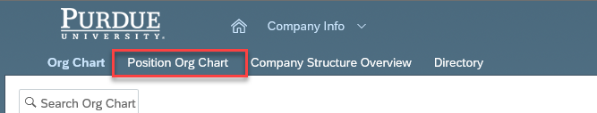
If Positions is selected, type the Position ID that you want to either add a peer position to or add a lower level position to in the Search box. (You can also Search by Name, if you know the name of the employee in the position you are looking for.)  Click to select the Position once displayed. | 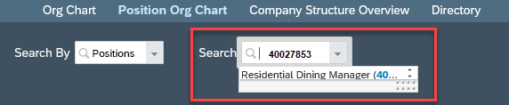
The Position entered will be displayed as an Org Chart Box.  If direct reports exist, they will populate below the Position box. | 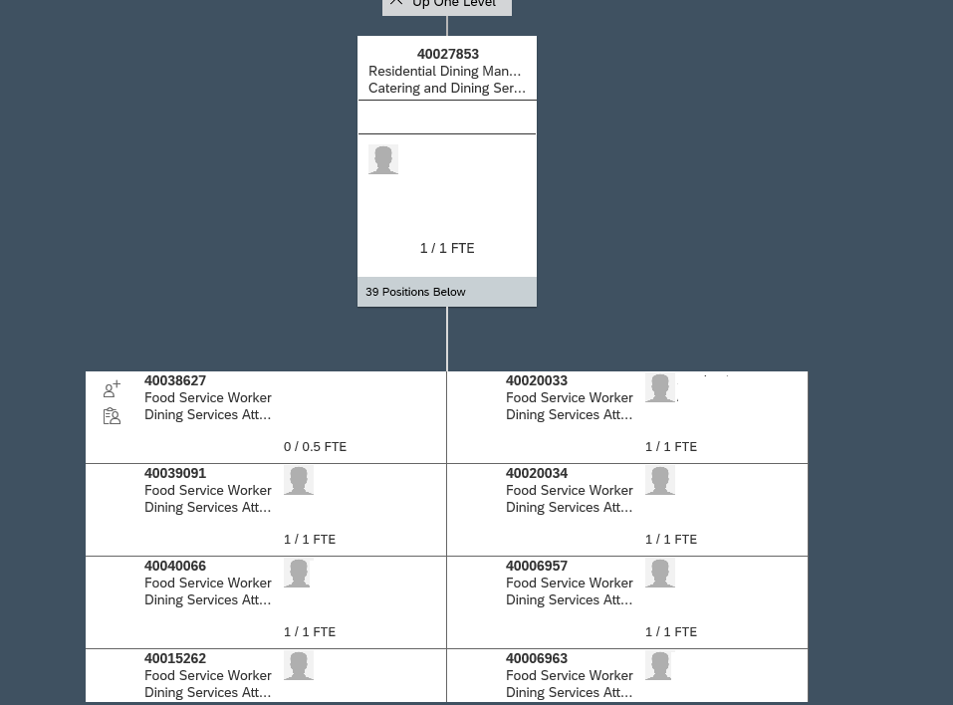

Creating a Position - Add Peer Position
To create a position by adding a Peer Position  - click inside the position box  - Once the Position ID box is displayed, click the Show Menu icon ()  - Click Add Peer Position | 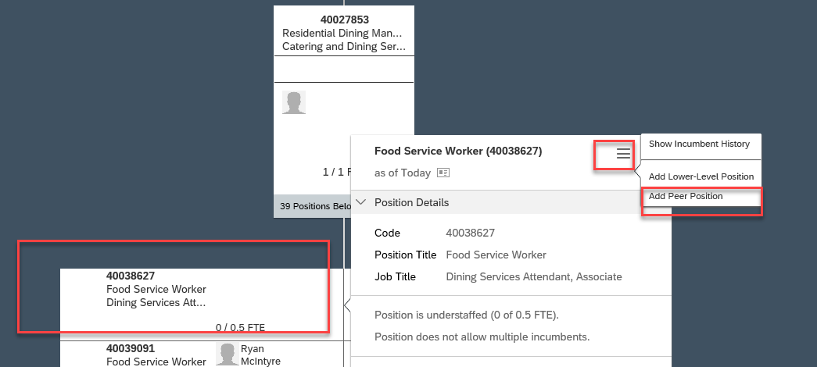
The Position: Auto screen is displayed with data pre-populated.  Update data based on the position request.  For guidance and definitions regarding each of the fields and tips for completing them, please see the Purdue Global Position Field Overview guide.  Notes on Start Date field:  - Do NOT use a future date when creating a new positon. Use the current date, or a prior date if the person going into the positon started prior to the current date. (e.g., today is 1/16/21, a new staff position is in effect 1/1/21. The start date field when creating the new staff position should be to 1/1/21.)  Make sure to reselect the Job Code if the Job Code is remaining the same or change the Job Code based on the needs of the position. Reselecting the Job Code ensures the correct Career Stream is populated.  Select the appropriate Location Group - Purdue Global (PG)  Select the appropriate Location:  - PG – Remote if employee is working remotely  - PG – WL if the employee is working onsite at the West Lafayette campus.  Select the appropriate Location Status  - Remote – 100%: majority of work is done on a computer and collaboration can occur virtually through email, phone, text, instant messaging, and/or video conference; work is performed independently and does not require a high level of manager oversight.  - Please note when the position is filled this field should be updated with Remote – State from the picklist.  - Hybrid/Rotational: job is capable of remote work, but may require some on-site work days to accomplish tasks that cannot be performed while remote (choose option that most closely represents ongoing schedule for the position); on-site = West Lafayette campus  - Hybrid (Remote) 25% - (On-Site) 75%  - Hybrid 50/50  - Hybrid (Remote) 75% - (On-Site) 25%  - On-Site – 100%: job requires a physical presence to perform the work; job duties may require the use of equipment, dedicated work space, service, delivery, or public safety; manager oversight is often required; on-site = West Lafayette campus  Select the appropriate Essential Worker Status  - Essential: Position a department has deemed critical and necessary to keep the core operations and infrastructure running on a bare minimum level.  Once all updates are complete, click Save. | 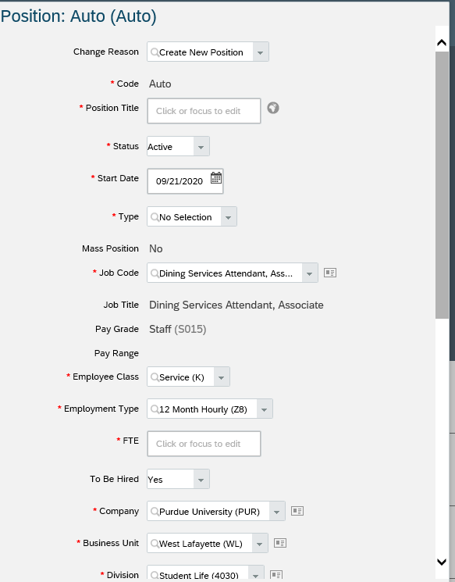
The Confirm Request box is displayed.  Type any comments associated with the new positon created in the comment box.  When complete, click Confirm to initiate the workflow process.  Note: Click the View Workflow Participants link to view the individuals associated with the workflow process. | 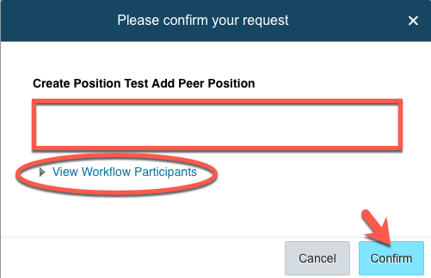
The pre-approved Position record is displayed. The position has been sent to the HR Admin-Position role for review and approval. | 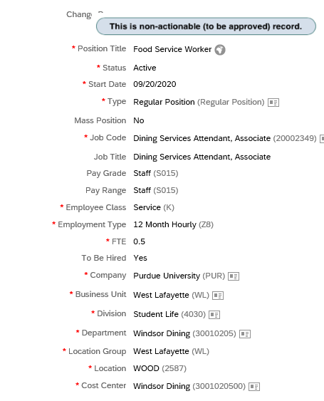

Creating a Position – Lower Level Position
Once the Position ID box is expanded, click on the Show Menu icon.  A dropdown menu appears.  Scroll down to Add Lower-Level Position and click to select. | 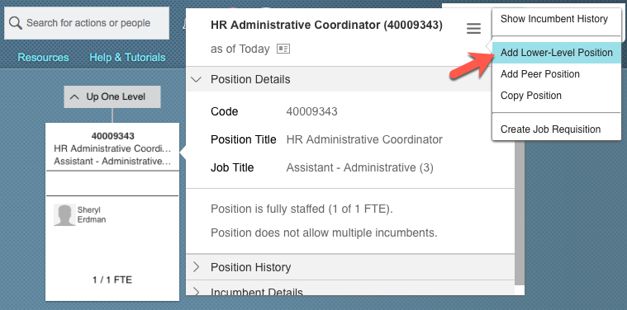
The Position: Auto screen is displayed with data pre-populated.  Update data based on the position request.  Notes on Start Date field:  - Do NOT use a future date when creating a new positon. Use the current date, or a prior date if the person going into the positon started prior to the current date. (e.g., today is 1/16/21, a new staff position is in effect 1/1/21. The start date field when creating the new staff position should be to 1/1/21.)  Make sure to change the Job Code based on the needs of the position.  Once all updates are complete, click Save. | 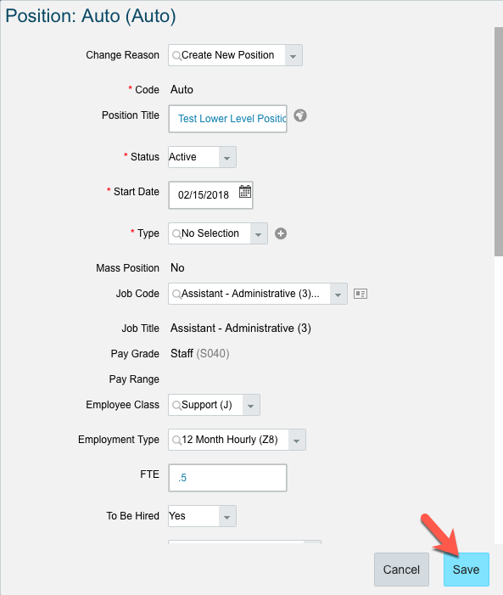  1
The Confirm Request box is displayed.  Type any comments associated with the new positon created in the comment box.  When complete, click Confirm to initiate the workflow process.  Note: Click the View Workflow Participants link to view the individuals associated with the workflow process. | 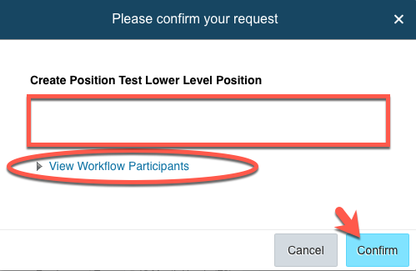
Note: If this position is to be immediately placed into the recruitment process, record (write down) the Position ID number so you have it accessible when initiating the requisition.  If you are not initiating the recruitment process, provide the Position ID number to the individual who will be initiating Recruitment. (The position will not be available to begin recruitment until it has been approved).  The pre-approved Position record is displayed. The position has been sent to the HR Admin-Position role for review and approval. | 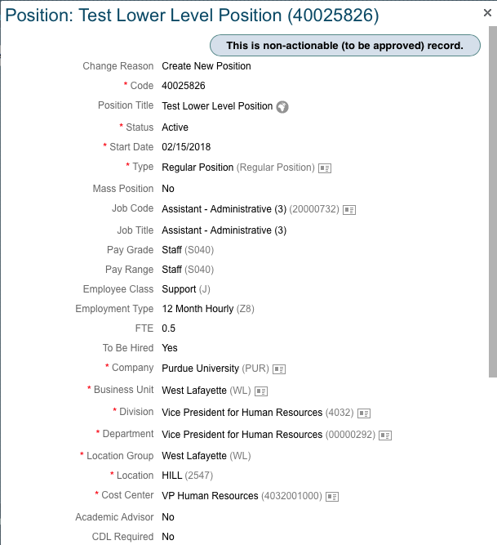  Position ID  1

